AMAZON MESSAGE QUEUE (mq)
Amazon MQ is a managed message broker service that makes it easy to set up and
operate popular open-source message brokers like Apache ActiveMQ and
RabbitMQ in the cloud.
The primary reason to use Amazon MQ is migration. If you are moving an
existing on-premises application that relies on specific APIs like JMS (Java
Message Service) or protocols like AMQP, you can migrate to Amazon MQ without
rewriting your messaging code.
Scenario
A banking application processes:
-- customer transactions
-- payment requests
-- fraud detection events
Different applications must communicate reliably.
Instead of directly connecting applications, we use Amazon MQ as a message
broker.
Create Broker
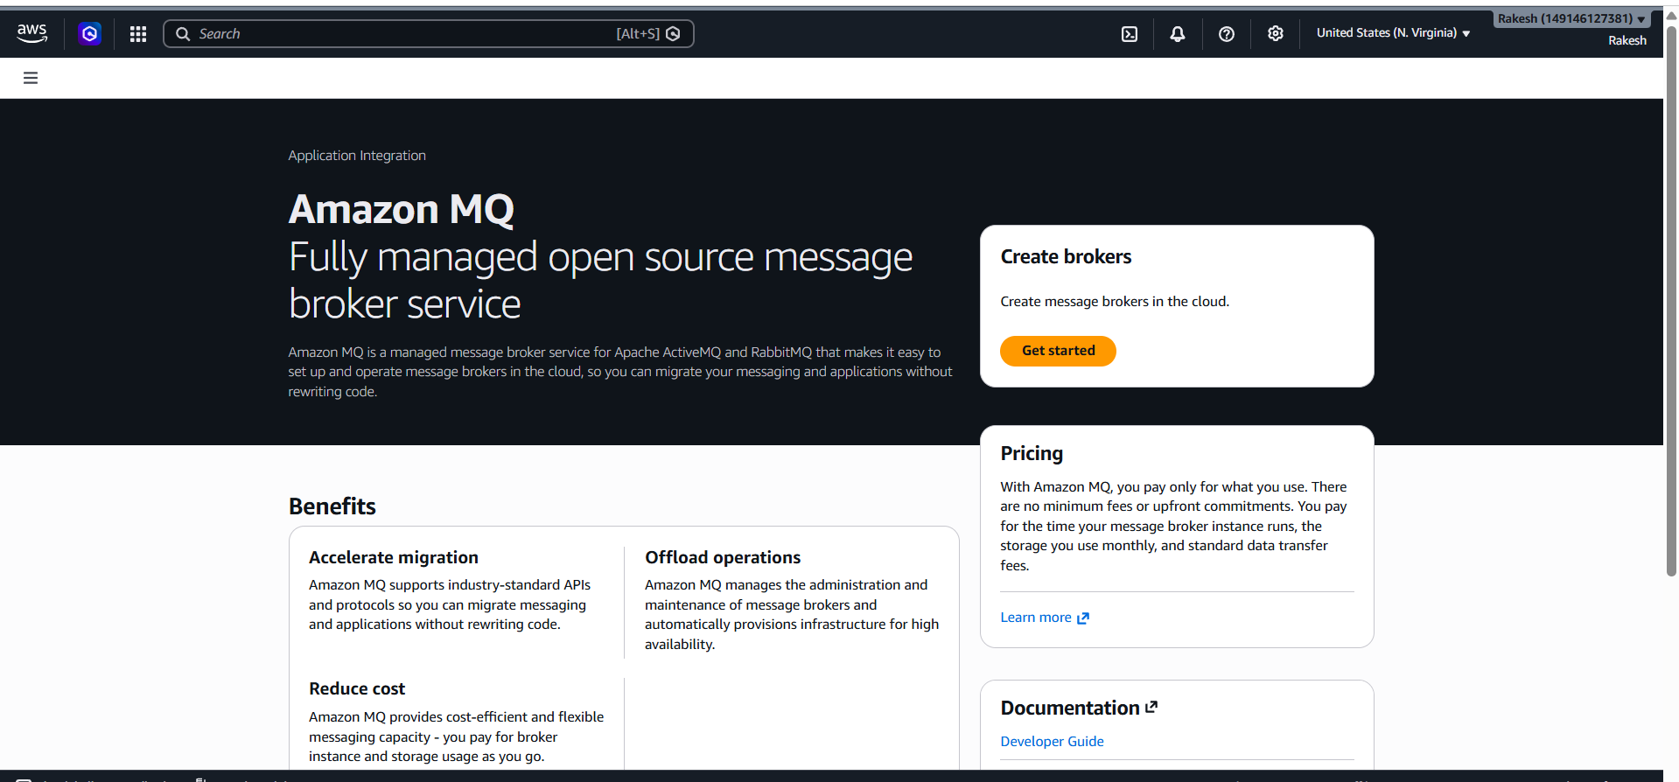
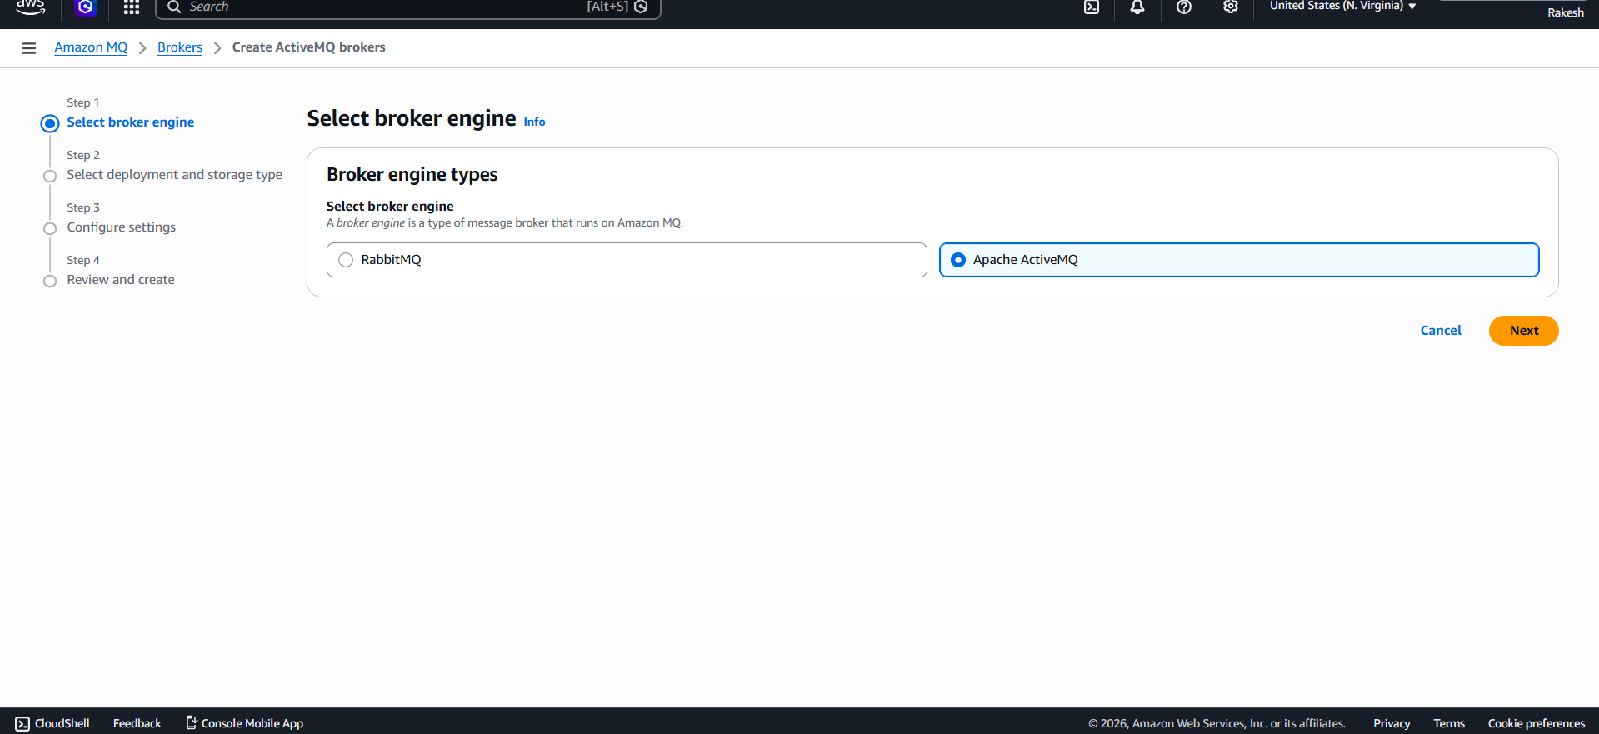
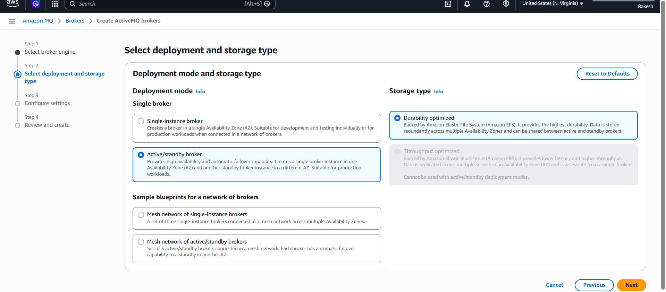
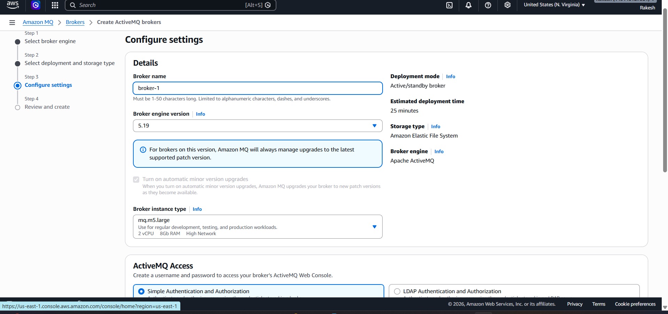

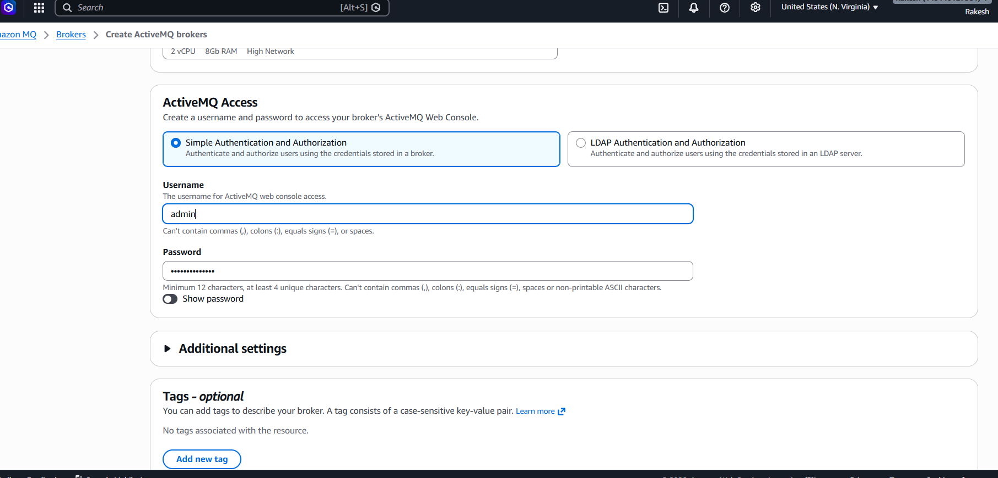
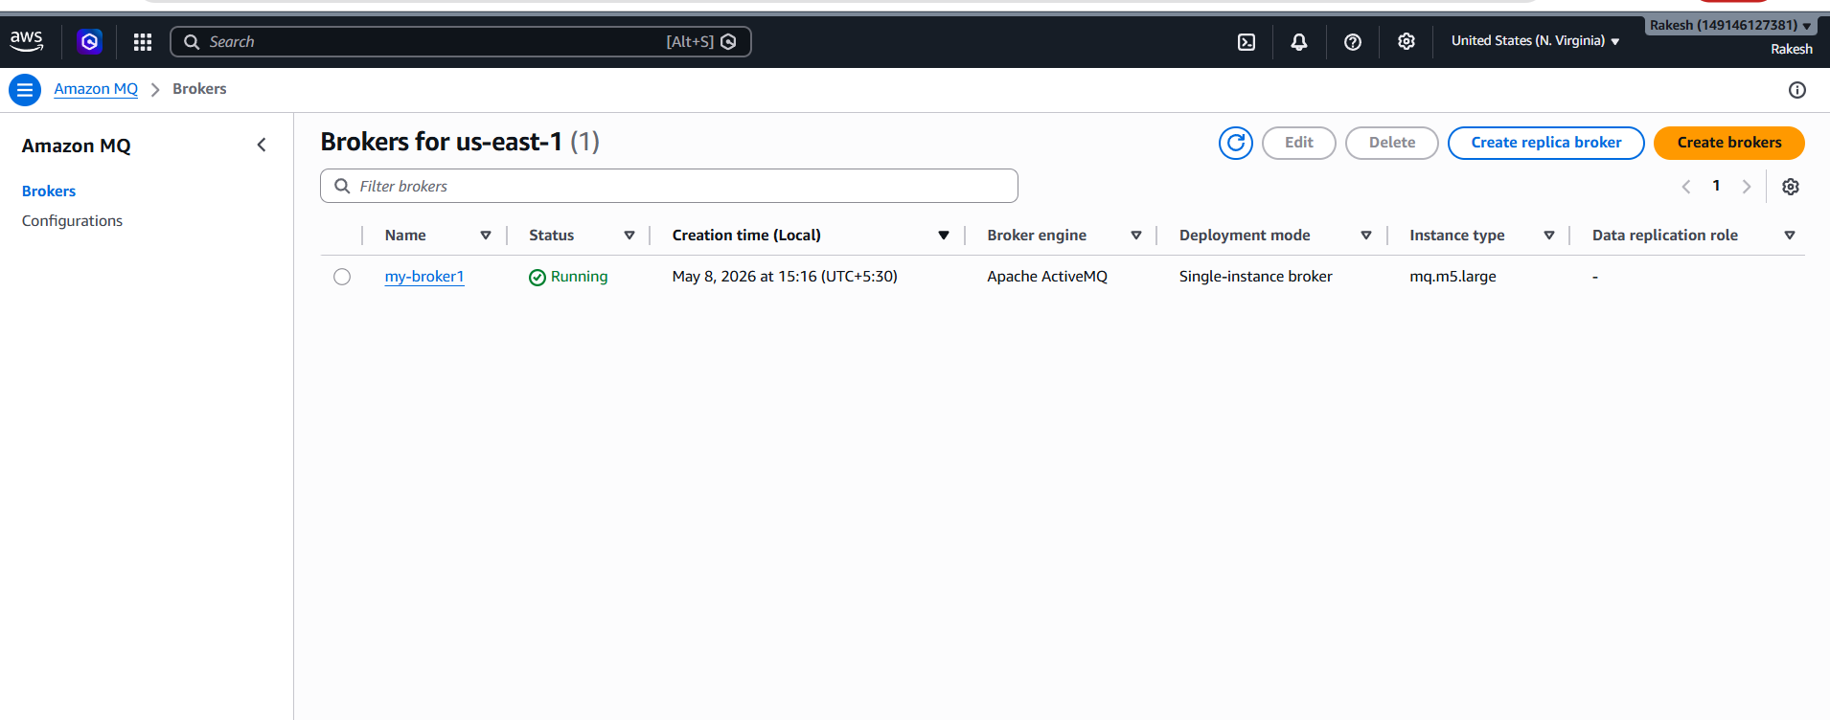
Click on the url
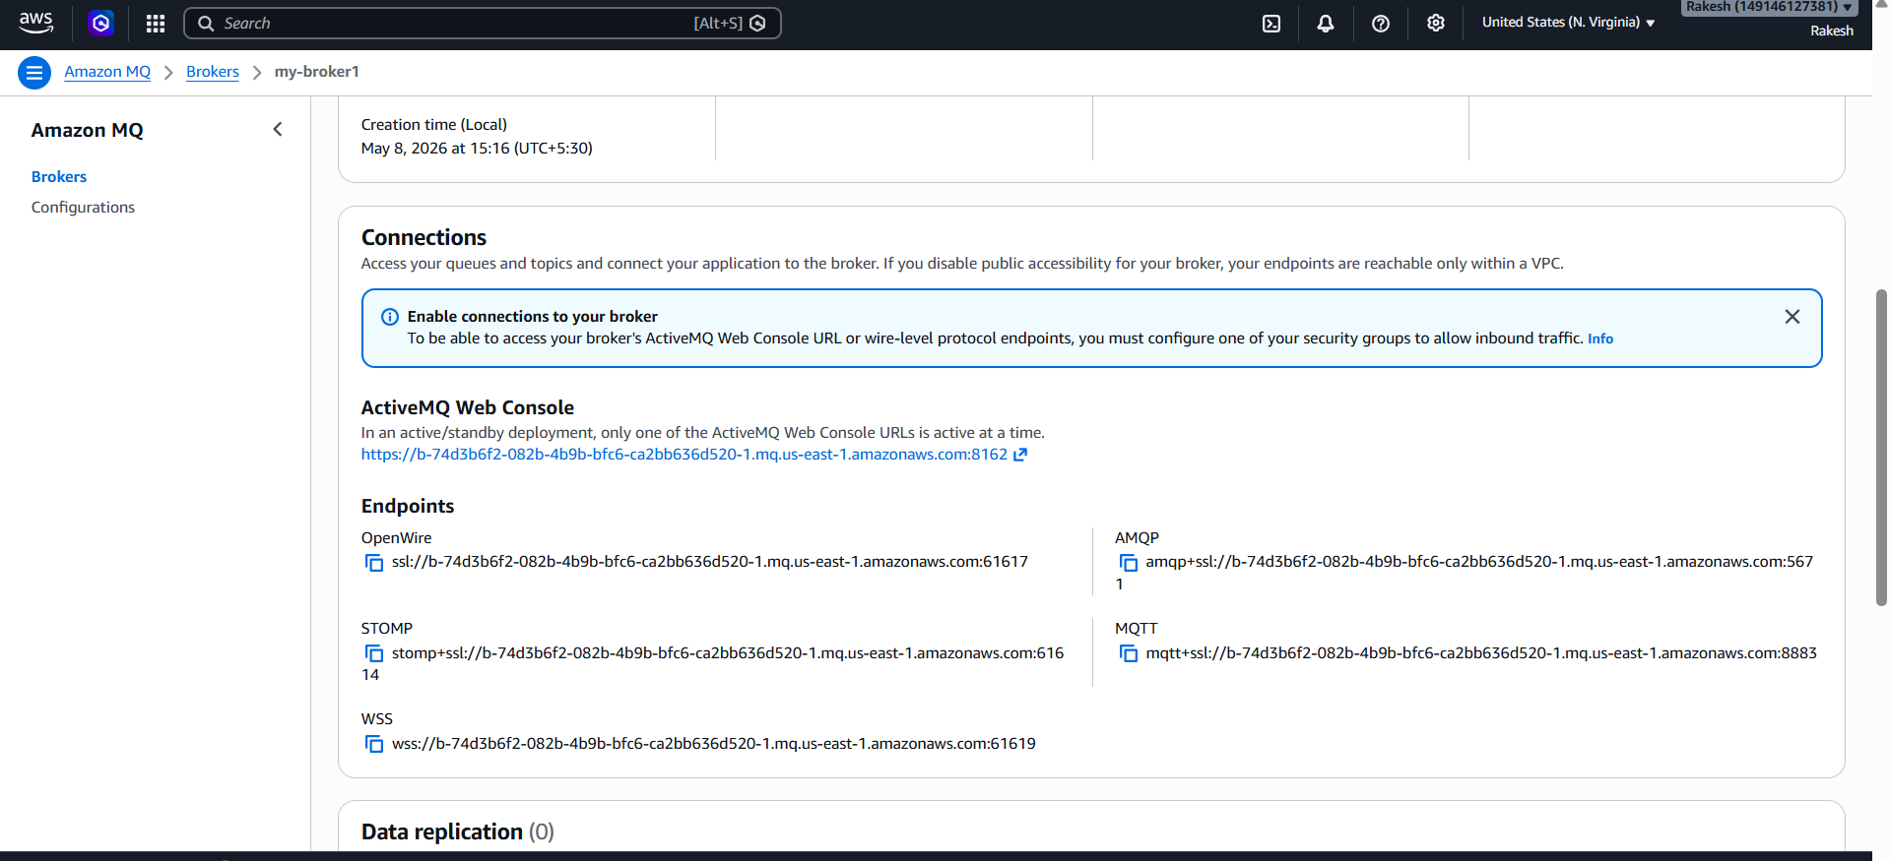
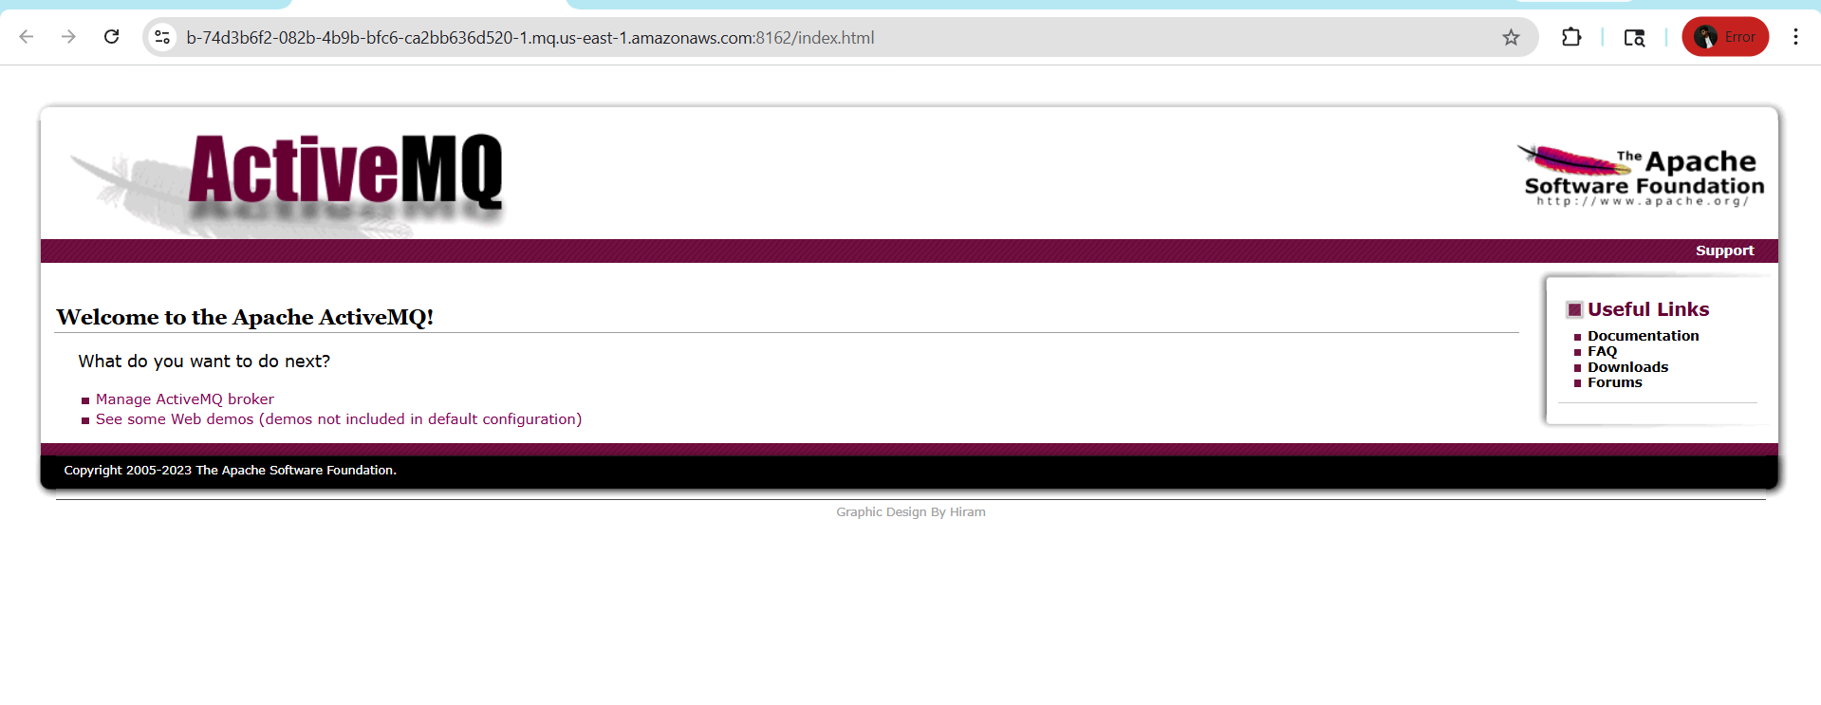Login by clicking on manage ActiveMQ broker
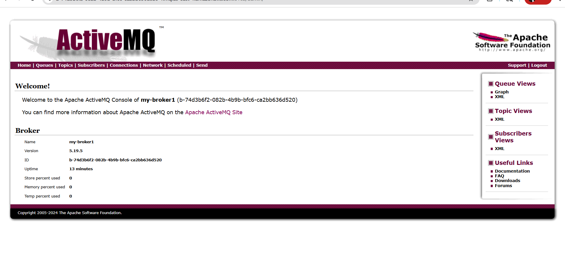Create queues
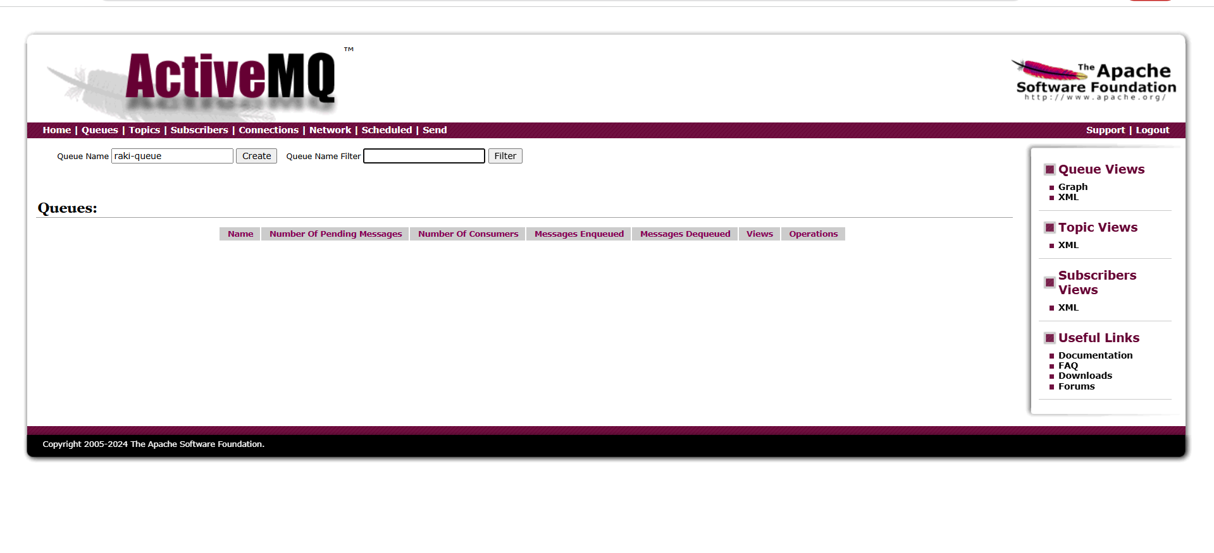
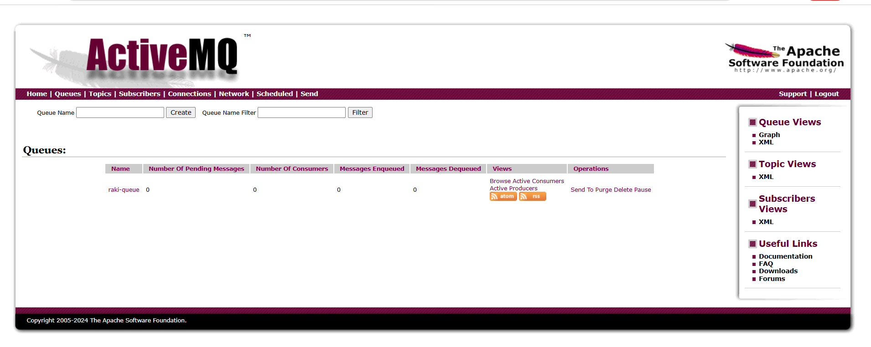

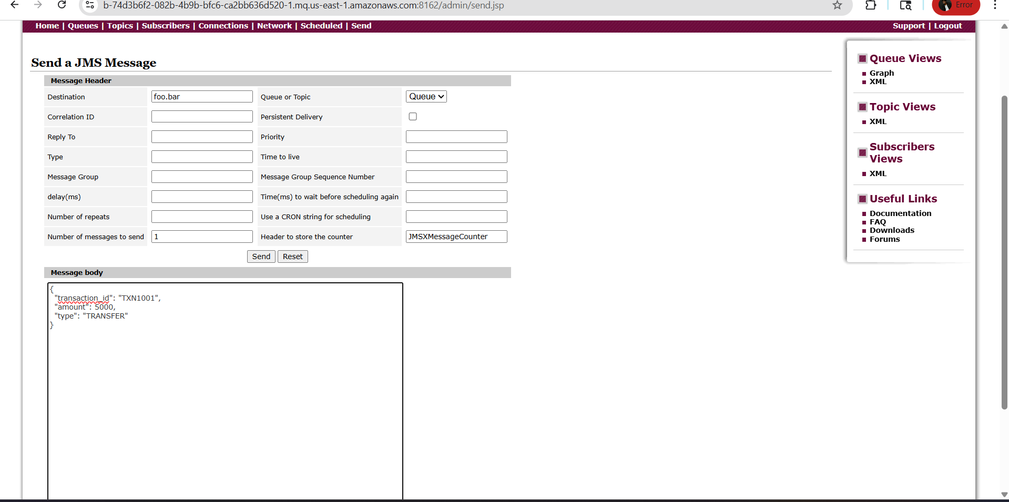
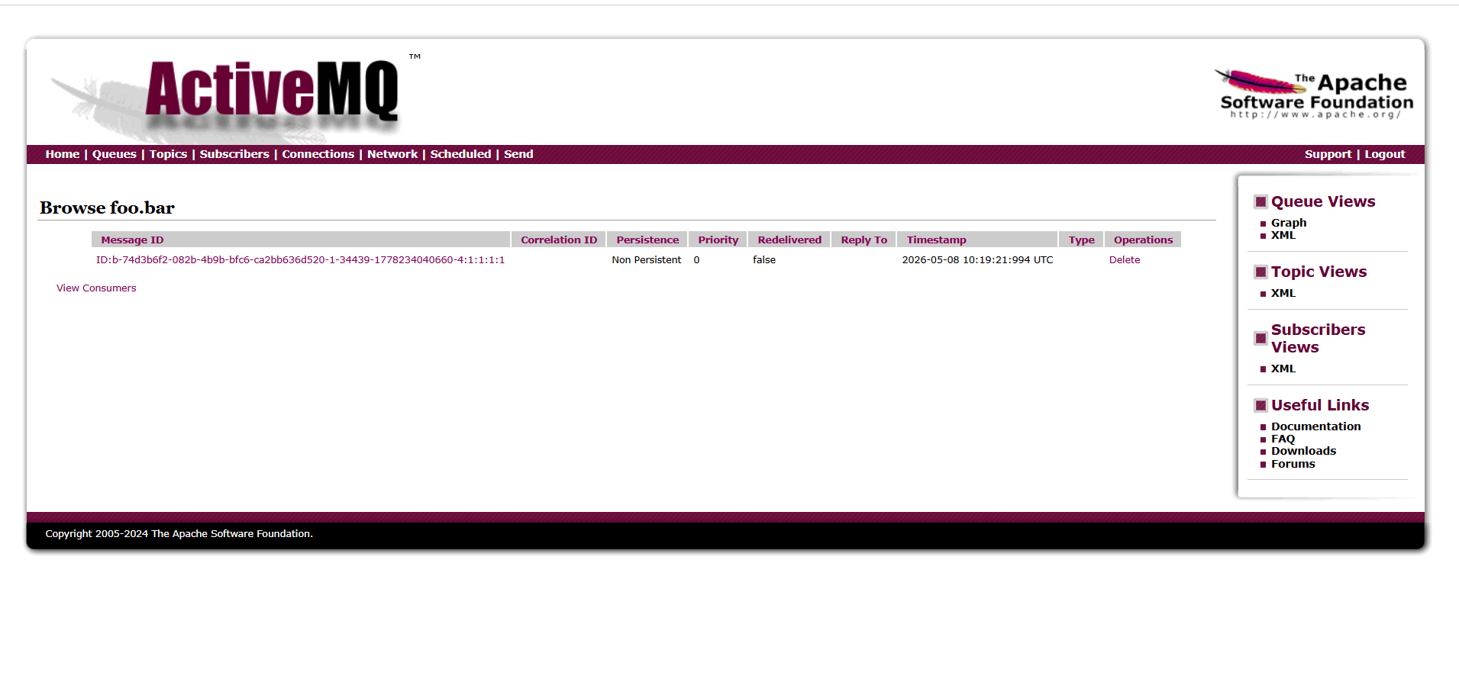
We can see the message
